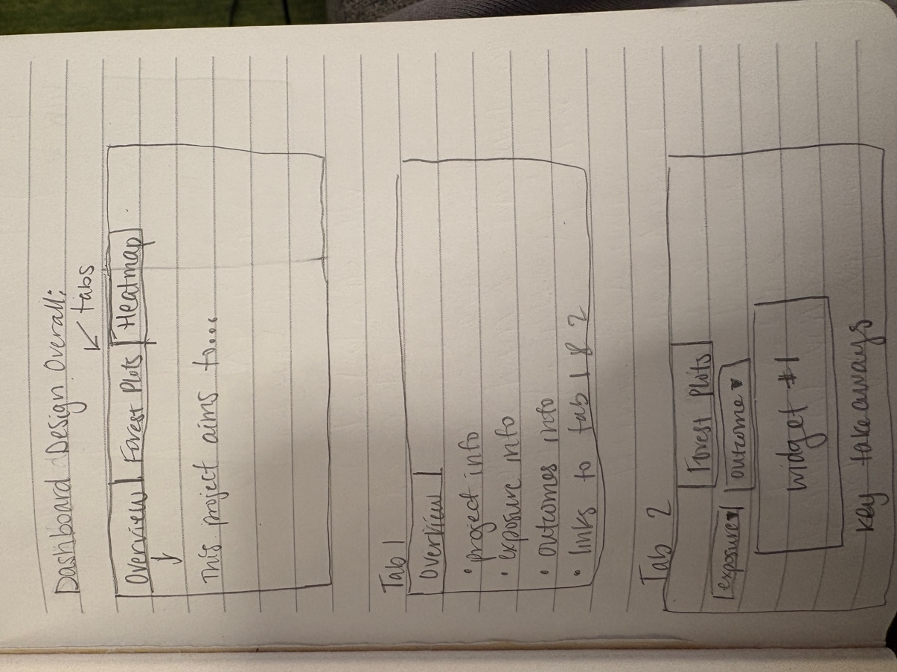
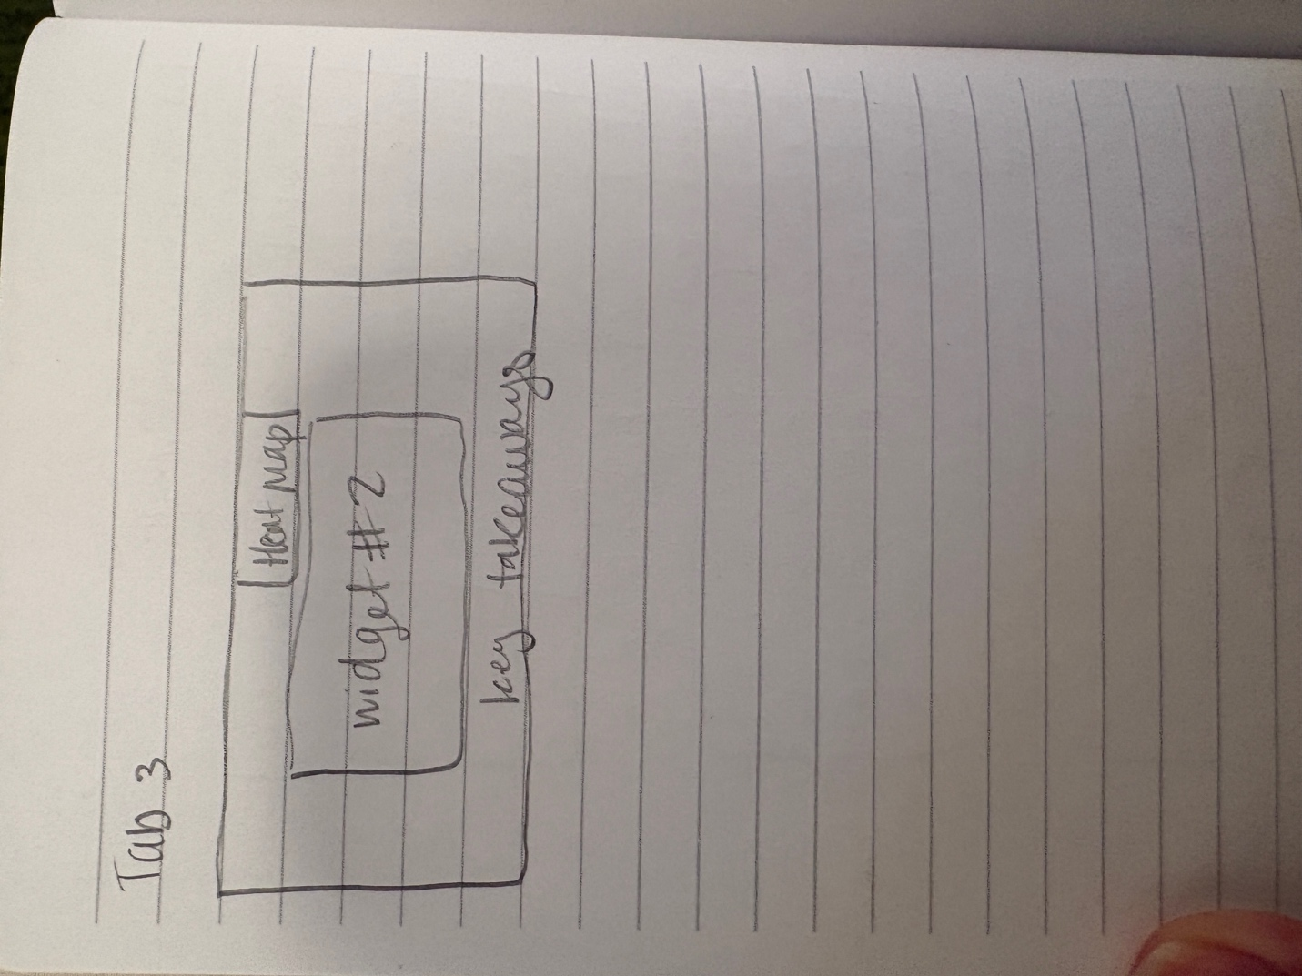
- The dashboard is organized using a tab-based layout to separate content into clear, purposeful sections and includes an overview tab, a forest plot visualization tab, and a correlation heatmap tab. This structure reduces visual clutter and allows users to focus on one visualization at a time. The overview tab provides essential context about the study, exposures, and biomarkers before users engage with the data, while the subsequent tabs present the primary and secondary analyses in a logical sequence.

- The tab-based design supports System 1 thinking by simplifying navigation and reducing cognitive load. Users can quickly identify where to go based on clearly labeled tabs, without needing to scan a dense page of information. Within each tab, visual elements such as aligned forest plots and color gradients in the heatmap enable rapid pattern recognition. The separation of content into distinct views allows users to process information more efficiently and intuitively.

- System 2 thinking is activated by enabling focused, deeper exploration within each tab. Users can interact with filters in the forest plot tab to examine specific exposure-biomarker relationships and interpret confidence intervals more carefully. The correlation heatmap tab supports detailed evaluation of pairwise relationships, with exact values and qualitative interpretations available through hover interactions. By isolating each analytical component, the design encourages users to engage more deliberately with the data and draw more nuanced conclusions.

